21.18: The charge 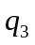 must be to the right of the origin; otherwise both 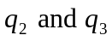would exert forces in the + x direction. Calculating the magnitude of the two forces:
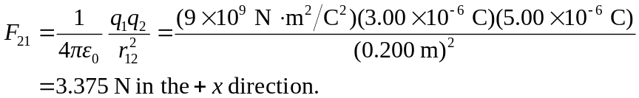

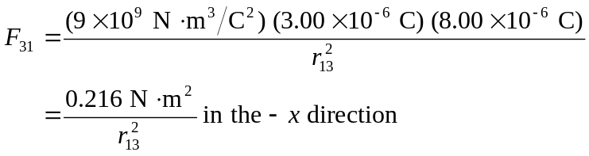
We need 